S5,6 tables: is it used in exercisesfor that lecture?
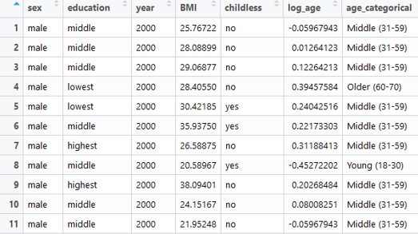
Similar style table repeats 5 times:
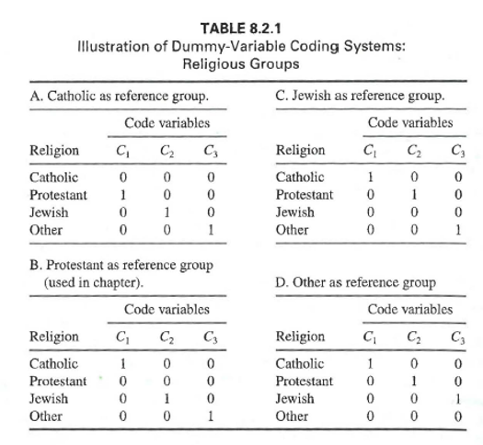
-What to do on install and load exercise..
-Exercise segmentation script vs. instructions

